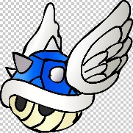**MarioKart**

In groups of two you should complete the MarioKart Game: You all need to do a half of the coding work and push your own work to GitHub. You should always work on a branch for each feature and merge into master on the local PC then push to GitHub. Your code should always compile and your game run (not gameplay) as soon as possible. Do not just type out each file one at a time and then merge them all unless you want a job as a “technical typist”. The code is included in pdf format read the code for the entire project and don’t start your code till you understand how the code on the current branch works. When typing code only add code relevant to the branch you are currently working on.

Assignment url https://classroom.github.com/a/Laj8ag81

The first person in a group should create the group when accepting the assignment and subsequent members select that group when accepting. Each member should create a branch named after them and add their name to the author section of game.cpp and merge it into master and push to GitHub. You must not use this branch for any code just your name in the comments once at the start.

# Suggested branches / features

Splash screen

Licence screen

Main menu

Help page

Game play

Input

Drawing

Game rules

Debug info FPS etc.

This is not graded but your big game project will be expected to have multiple screens \scenes\modes.

We will be working on this for two Fridays so expect to put 8 hours into this project.